Contractor Connect Skill Evaluation Sheet
Candidate Name: | Inuganti Prerna |  | 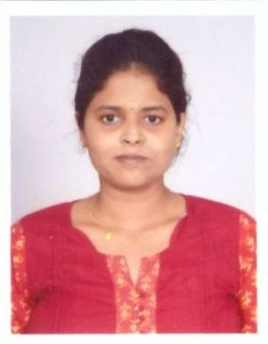
Total Experience: | 4.5 years
Relevant Experience: | 2.0 years
Notice Period: | Immediate
MSP Input |  | Supplier Input
Candidate Skills | Mandatory/ Optional | Name of Projects in which  the skills were used  (Add rows if necessary) | No: of years worked  in each Project | Description of work done  using the skill
Primary Skill 1: | M |  |  | Provide Demo to the clients on the functionality of SAP ARIBA
Primary Skill 2: | M |  |  | Documented and maintained technical specifications for SAP applications
Primary Skill 3: | M |  |  | Working on the B&I support project for PR creation, Approval flow creation, invoice and GR creation
Secondary Skill 1: | O
Secondary Skill 2: | O
Secondary Skill 3: | O

PRERNA INUGANTI
SAP ARIBA CONSULTANT

Hyderabad, India
8121019590
prernainuganti@gmail.com
Organized and dependable candidate successful at managing multiple priorities with a positive attitude. Willingness to take on added responsibilities to meet team goals.
Work History:
SAP Ariba Consultant | Cognizant
Hyderabad - April 2021 - April 2023
- Delivered SAP training, user support and knowledge transfer at end of project and followed up to verify successful implementation.
- Tested troubleshooting methods and documented resolutions for inclusion in knowledge base for support team use.
- Knowledge of Upstream and Downstream e.g. Sourcing, contracting, SLP & B&I
- Working on the B&I support project for PR creation, Approval flow creation, invoice and GR creation
- Monitor the issue around B&I module and train EU & supplier for any issue
- Creation on Contract terms/Compliance
- Provide Demo to the clients on the functionality of SAP ARIBA
- Coordinate with ERP consultant and facilitate CIG issue around PR to PO issues
- Knowledge of CIG implementation with downstream- creating integration project and checking transaction tracker for any issues.
- Documented and maintained technical specifications for SAP applications.

Senior Process Executive |Cognizant
Hyderabad - November 2018 - March 2021

- Generated monthly metric reports, interpreted results and developed processes and solutions.
- Provided strategic and operational recommendations for improvement across departments.
- Evaluated emerging technologies to identify opportunities, trends and best practices to strengthen business platform and development practices.
- Evaluated ongoing processes for possible enhancements and beneficial changes to best practices.

Technical Profile

- Microsoft Office
- C
- SQL
- SAP ARIBA

Education summary

2012-09 to 2016-06

Bachelor of Technology in Electronics and Communication Engineering at Sri Prakash College of Technology, Rajahmundry-India.

Interests

Writing

Painting

Travel

